Frequency Converters
Frequency Converters are used for converting either 50Hz, 60Hz, or 400Hz, utility line power to 50Hz, 60Hz or 400Hz power to run your mission critical equipment. All Ability Power solid state frequency converters use IGBT technology and are designed for continuous operation.

Detailed monitoring by alphanumeric LCD panel
• Dual microprocessor control
• 128 log event recording with RTC
• Separate battery supported clock and calendar
• RS232 or DRY contact relays.
• Custom input voltage and frequency ranges
• 3 phase or single phase options
• SNMP communication

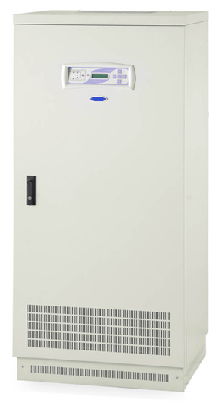

INPUT
Voltage | 220/230V single phase - 380/400V 3 phase ± 15% (for other voltages contact us)
Frequency | 50Hz /60Hz /400Hz (± 5%)
OUTPUT
Power | 5kVA to 300kVA 50Hz /60Hz /400Hz
Voltage | 120/208V 60/400Hz - 230/400V 50/60Hz. (other voltage ranges available)
Voltage regulation | + 1% (balanced load) + 2% (unbalanced load)
Frequency | 50/60/400Hz.
Frequency stability | + 0.2 Hz (free running)
Efficiency | 85% - 90%
Protections | Short circuit protection, overload protection, output voltage out of tolerance protection
Voltage protection | AC voltage low and high protection
Output waveform | THD < 3% for linear load
Output power factor | 0.7 (single phase) - 0.8 (three phase)

